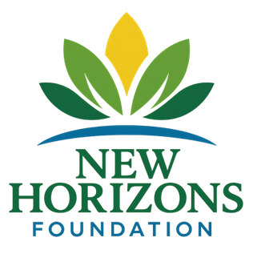
NEW HORIZONS MENTAL HEALTH FOUNDATION
2026 Youth & Family Early-Intervention Initiative
Local Mental Health Prevention for North Texas Families

WHAT WE’RE DOING
We are expanding early-intervention mental health education across Collin County and surrounding communities to help families:
• Recognize early warning signs
• Support youth before crisis
• Reduce stigma
• Strengthen family resilience
Goal: Reach 5,000+ North Texas families in 2026

WHY THIS MATTERS LOCALLY
• Youth anxiety and depression rates continue to rise
• Schools and parents are overwhelmed
• Prevention reduces crisis-level costs
• Strong families build strong local businesses and communities
This initiative supports the very families who live, work, and purchase in your service area.

FAST SPONSOR OPTIONS
$10,000 — Premier Community Partner
• Large logo placement on all initiative materials
• Recognition at live events
• Press release inclusion
• Social media spotlight
• Event banner presence
• Optional employee mental health literacy workshop

$5,000 — Community Sponsor
• Logo placement on materials
• Social media recognition
• Event signage acknowledgment

$2,500 — Local Supporter
• Website recognition
• Event acknowledgment

WHAT YOU RECEIVE
• Public recognition
• Community goodwill visibility
• Impact summary report
• Tax-deductible contribution
• Alignment with youth and family wellness
SIMPLE DONATION PROCESS

✔ Make check payable to: New Horizons Mental Health Foundation
✔ EIN: 41-3658405
✔ 501(c)(3) Public Charity
✔ IRS Determination Letter available
Mail to:
4817 Medical Center Dr Unit 3A
McKinney, TX 75069
Or scan QR to donate online.

CONTACT
Dr. Dean Aslinia - Executive Director
DrDean@TheNewHorizonsFoundation.org – www.TheNewHorizonsFoundation.org
623-296-0402
Strong Families. Resilient Youth. Proactive Communities.

